Technical University of Munich (TUM)
School of Computation, Information and Technology

Foundations and Applications of Generative AI (CITHN2014)
Group Project: Proposal [Draft 2]

Jingyi Shao (03798142)
Yilang Mei (03759865)
Sihao Tao (03793452)
Swaraj Shrestha (03816043)
Trinh Nguyen (03824365)
Zijian Luo (03817807)
Xinyi Li (03814492)

Topic: Project 4 – GTM Agent
Partner: None (ArctisAI has withdrawn; the team is continuing the project independently)

- Project Description
GTM Agent will be an autonomous, agent-based pipeline designed to revolutionize B2B business development in several vectors. Tenders currently identify the right lead at the right time; our system will automate this by monitoring EU tender portals to identify active projects, then deploying agents to scrape participating companies' websites to understand their technical backgrounds.
The core innovation will lie in the Context-Aware Personalization Engine, which combines complex tender requirements with a company's specific history to generate personalized outreach. Unlike generic "LLM wrappers," our system will manage a multi-step workflow: (1) data ingestion, (2) lead qualification, (3) draft generation. Culminating in a centralized dashboard for sales teams to review and refine high-value leads.
- Key Deliverables
Given the course requirement for a complete software system, the deliverables are categorized to ensure both backend robustness and frontend utility.
Mandatory Features:
- Tender Portal Monitor: A backend service to scrape and parse structured/unstructured data from EU tender portals
  - [NEW] Industry Scope via CPV Codes: We narrow the agent to 2–3 high-value sectors (e.g. Construction, Renewable Energy, IT/Cyber) by filtering TED on CPV (Common Procurement Vocabulary) codes. This gives us a controlled, evaluable scope and a sharper notion of “relevance” than a generic, all-domain crawl.
  - [NEW] Dual TED Data Stream (Contract Notices + Contract Award Notices): TED exposes two complementary feeds: Contract Notices (active tenders) and Contract Award Notices (past results, including the winning bidder). We use Contract Notices to identify the live tender, and Contract Award Notices as our primary source of candidate “close bidders”, companies who previously won similar projects (same CPV, same buyer, similar budget). Wider web search is used only as a fallback when historical award data is sparse for a given tender.
  - [NEW] Tender Section Identification & PDF Dossier Following: Beyond ingesting the JSON metadata, the agent identifies the main sections of each tender (deadline, budget, eligibility, technical requirements, geographic scope, evaluation criteria) and follows links inside the notice to download the larger tender dossier PDFs (often 50–200 pages). A map-reduce summarization strategy is used so long documents do not suffer “lost-in-the-middle” context loss.
- Agentic Company Researcher: An AI agent that navigates identified company (the Bidder’s) websites to extract "Technical Focus" from past work and "Past Projects."
  - [NEW] Hybrid Matching Algorithm (LLM + classical ML + rules): Replacing the original “LLM-only” ranker, our matcher decomposes scoring into independent layers: (a) the LLM extracts structured fields from tender and company sources but does not rank; (b) Sentence-BERT computes semantic similarity between technical requirements and company portfolio for a 0–100 sub-score; (c) rule-based scoring handles budget fit, location, qualifications and certifications; (d) a logistic-regression model trained on historical wins recommends initial weights across these dimensions. This is the system’s core engineering contribution and the main novelty over an LLM wrapper.
  - [NEW] Hard Disqualifier Layer (negative matching): Before any scoring, candidates are passed through deterministic disqualifier filters: company blacklisted in EU procurement databases, geographic eligibility violation, company size clearly insufficient for the budget tier, or tender-specific exclusion criteria. Removing these candidates first prevents the matcher from wasting compute and produces cleaner, more trustworthy shortlists.
  - [NEW] Past-Win History as a Learned Signal: Each candidate company is also enriched with its TED win history (which CPV areas, which buyers, what budget bands). This becomes a feature in the logistic-regression weight learner, so the system gradually learns, for example, that for renewable-energy tenders in southern Germany, past-win history weighs more heavily than literal keyword overlap.
  - [NEW] User-Adjustable Weights with Real-Time Recalculation & Score Explanations: On the dashboard, sales staff see the model-recommended weights for each scoring dimension and can override them via sliders. Scores recompute live. Crucially, every company’s score is paired with a human-readable explanation (e.g. “Semantic match 85%” – the tender mentions ‘sensor networks’ and the company has experience with ‘wireless monitoring nodes’; budget fit 60%; past-win bonus +12”). => Human in the loop.
- Personalized Email Generator: A pipeline that combines tender specs and the research for the identifier bidder company to produce tailored Business Development drafts.
  - [NEW] Evidence-Grounded Email Generation: Before drafting, an extraction step pulls evidence-backed match points from both the tender and the company source material (with citations: which sentence in which document). The email LLM is then constrained to draft only from this verified evidence list, not from a free re-summary. This sharply reduces hallucination, makes every claim in the email traceable, and is a clean engineering layer rather than a prompt trick.
- A central storage (database) for tracking leads, company profiles, and email statuses.
  - [NEW] All artefacts (tenders, dossier PDFs, structured tender fields, company profiles, embeddings, scores, weights, generated emails, user thumbs up/down, and weight overrides) are stored in a single relational schema. Thumbs-up/down feedback feeds the logistic-regression weight learner, so the recommendations improve over time. This database is also what enables backtesting: we can replay past tenders against past awards to validate that our top-3 shortlist contains the actual winner.
Optional:
- [NEW] Multi-Model Embedding Consensus (open source): For semantic similarity we ensemble perhaps 2-3 open-source models: all-MiniLM-L6-v2 (fast), all-mpnet-base-v2 (accurate), and maybe multilingual-e5-large (cross-lingual), and average their normalised scores. This both removes single-model blind spots and lets us match a German company to a French tender, which matters because TED publishes in 24 official EU languages.
- A frontend dashboard (matching the course requirement) where users can view incoming tenders, review extracted company insights and edit generated drafts.
- LinkedIn integration by using specialized APIs to identify specific decision-makers (Project Managers/CEOs) within companies, or relevant past projects based on the tender-bid.
- A feature allowing users to "thumbs up/down" drafts, using the feedback to refine the LLM's prompting strategy over time?

- LLM API Integration
[NEW] Under the v2 hybrid design, LLMs are used as a constrained feature-extractor and a constrained generator, not as the ranker. Ranking, scoring and lead qualification are handled by classical ML and rule layers
- Information extraction: convert messy, legalistic tender notices and dossier PDFs into structured JSON (deadlines, budget, technical requirements, eligibility, evaluation criteria) using Chain-of-Thought prompts with strict schema validation.
- Map-reduce summarisation of long dossiers: chunk 50+ page PDFs into structured-field contributions, avoiding “lost-in-the-middle” context loss when reducing to a single tender record.
- Company profile extraction: parse scraped company websites into a fixed schema (technical focus, past projects, certifications, approximate size).
- Entity-resolution tie-breaking: when fuzzy string matching across notices is ambiguous (e.g., “Hochtief AG” vs. a local subsidiary), the LLM resolves the canonical company.
- Explicitly out of scope for the LLM: ranking, scoring and lead qualification, these are handled by the Sentence-BERT ensemble, the deterministic rule layers, and the logistic-regression weight learner

- Test Data or Input Sources
Input Sources:
- Official EU Tender Portals (TED) for real-time feeds of public infrastructure and construction bids. Encouraged to use the public API for projects that while free and accessible, has a Fair Usage Policy (https://developer.ted.europa.eu/home).
- Calibration testing using ideal customer profiles provided by the partner to check the "relevance" scoring of the agent.
- A curated list of 20–30 construction company websites to test the scraper’s ability to handle different site architectures.
- Simulated user behavior for A/B and UX testing

Sample Screens:
[Created using Gemini 3 Flash Image (Nano Banana 2). All data/information inside are AI generated and are not real tender projects or bidders.]
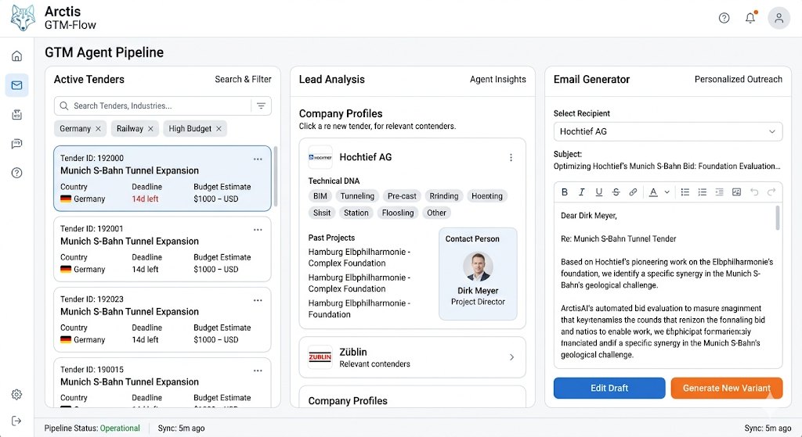
Three-Column Workflow: Tenders → Company Analysis → Email
- The 'Active Tenders' list must pull real (or simulated) data from your backend.
- Clicking a company like 'Hochtief' must trigger the backend agent to pull the corresponding scraped insights.
- The text generated in the 'Email Generator' must dynamically change based on the context of the selected tender/company pair
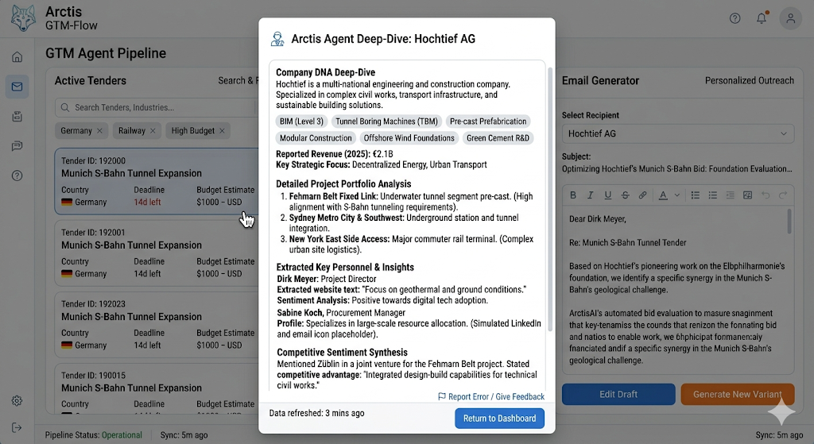
As a user clicks the ‘Hochtief AG’ entry in the central 'Lead Analysis' column. The backend agent has pulled detailed insights, which are now presented in a clear modal window

